1. Using a graph to illustrate slope and intercept, define basic linear regression.

Ans: **the equation of simple linear regression is: Y=Mx+C where M is the slope/coefficient and C is the intercept. The line passes through the origin when the value of C is zero. In linear regression, the best fit line is found which gives the most accurate prediction of target variables. We achieve the best fit line by minimising the value of the cost function after applying the optimization algorithm.**

1. In a graph, explain the terms rise, run, and slope.

Ans: **slope is calculated in terms or rise and run. Rise is the vertical increment and run is the horizontal increment. the formula for that is below:**

**Slope=Rise/Run**

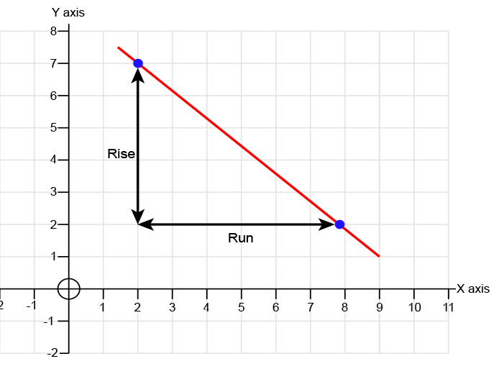

1. Use a graph to demonstrate slope, linear positive slope, and linear negative slope, as well as the different conditions that contribute to the slope.

Ans: **slope is same as what has been described in the previous question. It is essential to determine the slope of the line during iteration of the model to minimise the value of the cost function or aggregated error. Linear positive slope entails two variables being positively related meaning if one variable increases, the other also increases. On the contrary, negative slope shows the negative relation between two variables meaning if one increases, the other decreases.**

**The value of x and y, considering only two variables, contribute to the slope. Slope is different for different values of x and y.**

1. Use a graph to demonstrate curve linear negative slope and curve linear positive slope.

Ans:

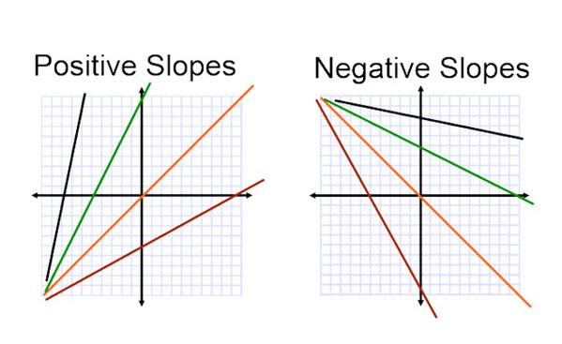

1. Use a graph to show the maximum and low points of curves.

Ans: **we use differentiation of a function to find the high and low points of a curve. That is why we apply the gradient descent algorithm to find the minimum value of the cost function, one of the pre-requisites is that the cost function should be differentiable so that the derivative of the function can be found.**

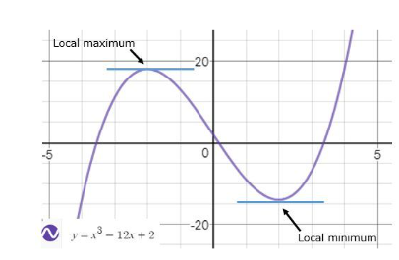

1. Use the formulas for a and b to explain ordinary least squares.

Ans: i**n OLS we use SSE as a cost function and aim to minimise the value of SSE by selecting appropriate value of a and b which is slope and intercept. We use below formula to calculate the slope and intercept:**

1. Provide a step-by-step explanation of the OLS algorithm.

Ans: **OLS algorithm is another method which is non iterative and is used to calculate the coefficients of the features. The coefficients are calculated using mathematical formula. It doesn’t use the gradient descent optimisation algorithm to minimise the loss function. However, OLS finds the coefficients by minimising the sum of squares**

1. What is the regression's standard error? To represent the same, make a graph.

Ans: **The error in regression is the difference between observed and predicted points. We add all the error for all the data points then we get sum of squared error where squaring cancels out the negative error.**

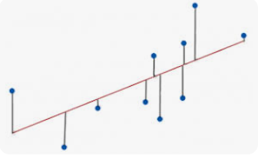

**Here the line shows the predicted points and dots show the observed points and the vertical line shows the error.**

1. Provide an example of multiple linear regression.

Ans: **In multiple linear regression, there are more than 1 independent variables. As a result, there are more than one coefficients as well to find the relationship between each individual independent variable and the target variable. the example of data set to show the affect of Engine size and number of cylinders in a car to predict CO2 emission. Here two variables are independent and 1 is dependent.**

1. Describe the regression analysis assumptions and the BLUE principle.

Ans: **there should be linear relationship between independent and dependent variable and there should not be multicollinearity in the independent variable meaning there should not be a strong relationship between two independent variables. That could be determined by checking the coefficients value of the variables. Another assumption is Homoscedasticity, meaning the error term should be constant as the values of the variable changes.**

1. Describe two major issues with regression analysis.

Ans: **Non linearity of the independent and dependent variables and Heteroscedasticity are the two major issues where regression model may not be a good model to employ.**

12. How can the linear regression model's accuracy be improved?

Ans: **there are multiple ways to improve the model accuracy.**

1. **The first way to improve the accuracy of the model is to make it as generalize as possible so overfitting can be prevented.**
2. **We can add more data points to have enough data to train the model**
3. **We must have quality data**
4. **There must not be multicollinearity and heteroscedasticity**
5. Using an example, describe the polynomial regression model in detail.

Ans: **Polynomial regression is a form of linear regression where the relationship between independent and dependent variable is nonlinear. When the nonlinear relationship is found we add some polynomial terms to linear regression to convert into polynomial regression. We convert the input variables into polynomial terms using some degree. The polynomial linear regression Is called a linear regression because the relationship between coefficients is always linear. In this the degree by which the input needs to be converted by is a hyperparameter and should be selected carefully.**

14. Provide a detailed explanation of logistic regression.

Ans: **Logistic regression is used for binary or multiclass classification problem where the target variable is a categorical variable. We use sigmoid function to squash the linear regression line between 0 and 1 and then use a log loss function as a cost function which is differentiable and convex in nature to enable us to apply gradient descent optimisation algorithm. The reason of using log loss function instead of MSE is that when MSE is used with the sigmoid function it creates non convex function on which Gradient Descent algorithm can’t be applied. The aim of Gradient descent is to minimise the value of the cost function by finding a global minima which means finding the value of coefficient for which the cost function/log loss is minimum.**

15. What are the logistic regression assumptions?

Ans: **Logistic regression assumption are similar to linear regression assumption including linear relationship between independent and dependent variable should be linear, meaning there should be increasing or decreasing trend between independent and dependent variable. there should be no multicollinearity, meaning no two independent variable should be highly correlated. Another assumption is homoscedasticity, meaning the data points should be about the same distance from the best fit line.**

16. Go through the details of maximum likelihood estimation.

**Ans**: **it involves maximising a likelihood function in order to find the probability distribution and parameters that best explain the observed data. The main aim of this is to maximise the objection function to derive the parameters of the model.**